**Applicazioni per Dispositivi Mobili**

**A.A. 2021/2022**

**NFT- SHOP**

**(Compravendita_NFT)**

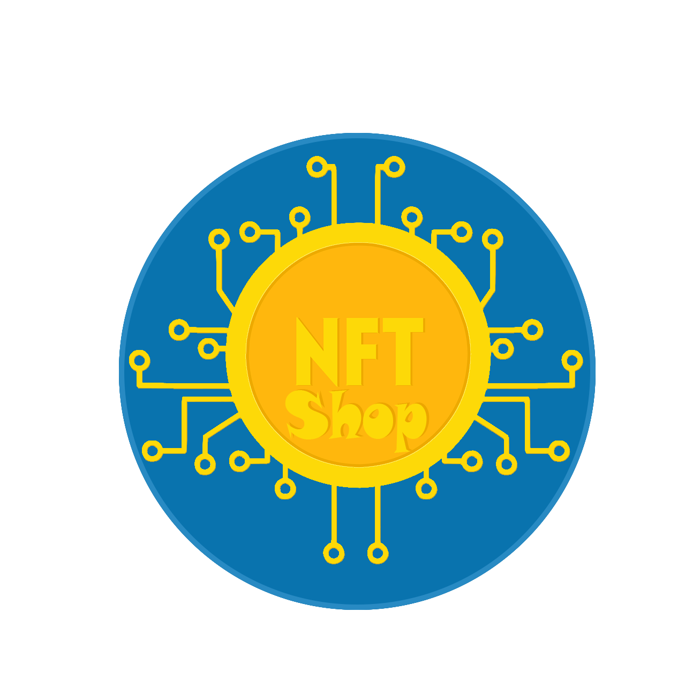

**Design documentation**

|  |  |  |
| --- | --- | --- |
| **Team Members** | | |
| **Name** | **Student Number** | **E-mail address** |
| Alessandro Di Benedetto | *265181* | alessandro.dibenedetto1@student.univaq.it |
| Pietro Pisegna | *265589* | pietro.pisegna@student.univaq.it |

Strategy

# Product Objectives

# Business goals

The Application’s purpose is to provide a commercial environment among NFT picture artists all over the world.

# Product Overview

NFT–SHOP is an APP that helps people & NFT artists to sell and buy NFT pictures, providing a stable platform and showroom to make themselves a name in the artistic business. This APP aims to be usable by a vast diversified audience, from expert artists to beginners and public / collectors.

# Competitors

Crypto.com: one of the first marketplace of NFT ARTs. It is an online platform providing multiple features, including NFT pictures. Its main issue is that it doesn’t provide a user-friendly environment to grow artists’ drawing skills.

**User Needs**

**Needs & goals**

We want the emerging artist to gain visibility, grow its business and skills, meanwhile expand their collection. We provide users with easy-to-use platform, a common marketplace, and a personal storage to save own NFTs; all done in few taps.

# User Research

A typical user session for this application has a medium-long period of activity because the user spends time searching, buying, and building his own NFT picture collection.

All features will be probably used in situations where the user isn’t in a hurry, and he is focused on the app usage.

# Personas

|  |
| --- |
| **Nickname:** Lukezoff1 |
| **Level of skill:** amateur |
| **Description:** I am an amateur of the art world. I want to try drawing pictures. |

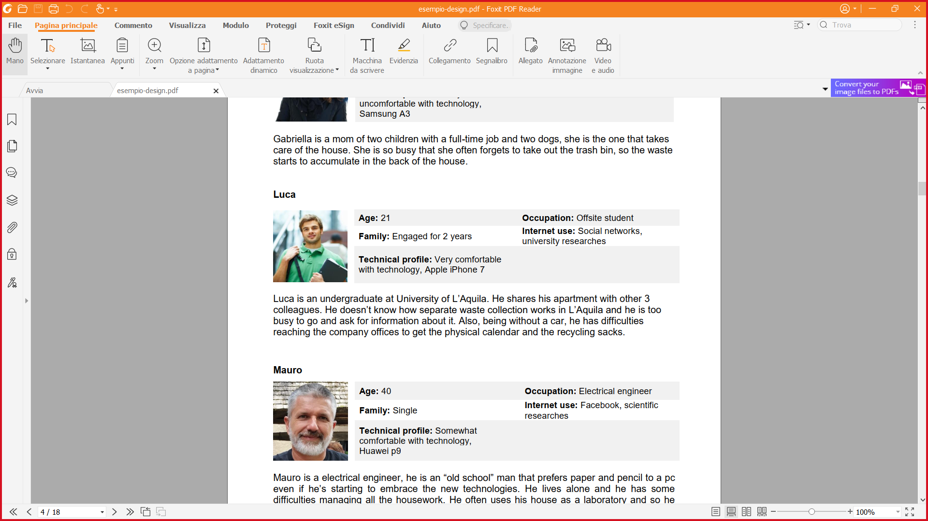

|  |
| --- |
| **Nickname:** Maurius324 |
| **Level of skill:** professional |
| **Description:** I love drawing since I was a child and I like collecting NFT pictures too. I’m now an expert of the environment but I’m not known a lot. I’m unemployed right now. |

|  |
| --- |
| **Nickname:** Gabry65 |
| **Level of skill:** amateur |
| **Description:** I’m not an artist and I can’t draw but I love collecting pictures representing landscapes. I’m a great collector. |

Scope

**Features**

* The application allows the user to **CREATE** a personal buyer-seller profile with only one action.
* The application provides users with an internal **MARKETPLACE** that permits users to buy/sell NFTs of their liking.
* Every user will be provided with a personal **STORAGE** to use as a **GALLERY** of NFTs.
* **LOGIN/LOGOUT.**
* Every user has the possibility to **ADD** NFTs in their gallery from external sources.
* Every user has the possibility to **DELETE** ownedNFTs only from their gallery.
* The application has its own **INTERNAL CURRENCY** (CASHART) to manage transactions. Every user will be provided with a fixed amount of CASHART at the first access.

**Other requirements**

* **SHOP WINDOW** common to all users where will be shown the last six added NFTs on the market.
* The user has the possibility to switch between **PERSONAL/PUBLIC COLLECTION** with the benefit of choosing which NFTs will be shown to other users when scrolling their profile.
* **NOTIFY** the user when the picture is sold with a summary of the transaction.
* The application **DOES NOT** permit users to create NFTs within the APP, because the app is not provided with an own editor nor linked to external editors.
* The user is provided with a **SEARCH** function. He can search between artist profiles and NFTs on sale.
* The application provides a brief **SUMMARY** of the last NFTs sold and bought in the private profile section for the user.
* The application shows a brief **SUMMARY** of the user’s on-sale NFTs in the public profile section.
* The application provides a **DETAIL PAGE** for each NFTs.

**Scenarios**



Luca is passionate of the art. He discovers the existence of NFT pictures, and he falls in love with the idea of drawing pictures himself. He has great ideas and a lot of spare time, but he is a beginner, so he wants to gain skills and improve his drawings. One day, his friend told him about NFT-SHOP, a great application for amateurs and professionals of the drawings. He thinks of using this app to improve his skills inspired by the works of other artists.

Mauro is a professional drawing artist. He has worked for a local newspaper as a cartoonist for 8 years. Recently the company’s financial broke and he became unemployed. He wants to continue his drawing career, so he started searching for a job. Eventually he got suggested, by his online research, of an app: NFT-SHOP. He decides to try it and started to post his artwork having a lot of success at that too. He became famous in a short time and eventually he got employed by a successful cinematographic company.

Gabriella is a famous art collector. She needs a digital platform to store and publicize her physical art collection. She wants also to know more about digital art and NFT artists, so she can expand her collection. After a brief research on the Internet, she discovers a perfect application that satisfies her needs: NFT-SHOP, the perfect app to store a personal collection in a safe place, share it with all the users and to discover new art talents.

Structure

# Navigation model

**Splash Screen:**

This is the opening view of NFT_SHOP. The user will see this view when he starts the app.

**Login:**

This is the login page, the user needs to login to use the app, if he put wrong credentials, he needs to login again.

**Register:**

This is the registration page, If the user is new, he needs to register first prior login in the app.

**Persistent tool bar:**

This is a tool bar that contains the icon of the hidden menu, the app name at the center and the internal currency of the current user which is given for free in 1000 units for the first login to start the adventure.

**Home:**

This is the main page of the app after the login, this house the shop window which contains the last 6 NFT items added, the button to navigate to the complete NFT shop and a footer that contains the creators’ nicknames.

**Hidden Menu:**

This view is the hidden menu, it’s always present during the app usage in all section, it can be accessed in all sections, it is a fast navigation tool, it is a showable list thanks to an icon on the upper left corner; here the user can choose to go in Profile, Gallery, Notifications sections and to Log Out the app.

**Notifications:**

This is the view where the notifications about items state are shown, when a item is sold it will be displayed here with all details.

**Gallery:**

This is the view of the user gallery, here he can find all possessed items with the possibility to add a new NFT items made with an external editor or hand draw, he also has the possibility to show some or all his NFT items with a switch or by holding a single item and tapping on whatever he wants to make public.

**New NFT item:**

Here the user can add his own NFT by loading the NFT picture and inserting all details and pressing the ADD button.

**Not On Sale NFT Item**:

This is the NFT item detail page where the user can find all its details with the button to sell the item.

**Sell NFT Item:**

Here the user can decide what price he want to sell for the NFT Item after he sold the item, he will be redirected to the home and the item will be added to the shop window and whole market.

**Shop:**

This is the complete shop where the user can find all NFT items in sale, the items are ordered by date, but he can order them by other criteria in the little select at the upper right corner, he can also access the search utility by clicking on its button.

**Search:**

This is the view where the user can search between NFT items and Users by selecting it on a select on the upper right corner, when the user selects the type of research, he wants to do he can type the name and press enter or the search button, each result is clickable and can take the user to its own page.

**On Sale NFT Item**:

This is the detail page of each NFT item in the shop, it shows all details and price, and the user can buy it with the Buy button only if he can afford it or go back to the shop with the go back button, there are also present the Seller and Author buttons to go directly to their pages.

**Profile**:

This is the page of the user profile that contains all of his info and two sections, one for the private side where he can find a brief history of his last bought and last sold items and the second for the public session where he can find a bunch of his public gallery items and his last on sale items all of those sections have a button to go directly to the own page.

**Public Section**:

**Public Gallery Not on Sale Item:**

Here is a detail page of the public item like the private gallery.

**On sale NFT items:**

This is the internal store page of the user where he can find all his on-sale item, each item will take the user to the detail page by clicking on it.

**Private Section**:

**Purchased NFT items History**:

This the history of user all purchased items with a brief list of transaction details.

**Sold NFT items History:**

This the history of user all sold items with a brief list of transaction details.

Each History has a single page connected to show all transaction and NFT item sold/bought.

# Data model

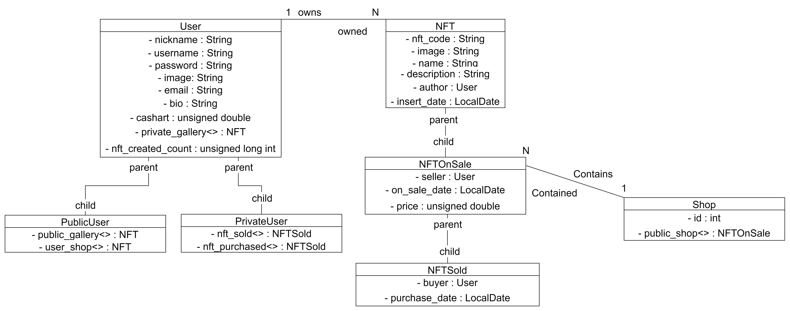

**User**:

The User entity represents the users with their basic information, with included the private gallery and public gallery that can contain the same items or less as the private one, no need to delete an item from one of those to display publicly.

The entity also contains the array list of sold and purchased items.

**NFT**:

This is the entity for representing an NFT picture, all its details as a non-sellable item.

**NFTOnSale**:

This is the entity that extends NFT which is used to sort and handle all items on sale which are taken out of the private and public gallery when are in sale with all their details.

**NFTSold**:

This entity represents the single item that has been sold to keep track of all sold items.

**Shop**:

This entity represents the list of items that has been set on sale.

Skeleton

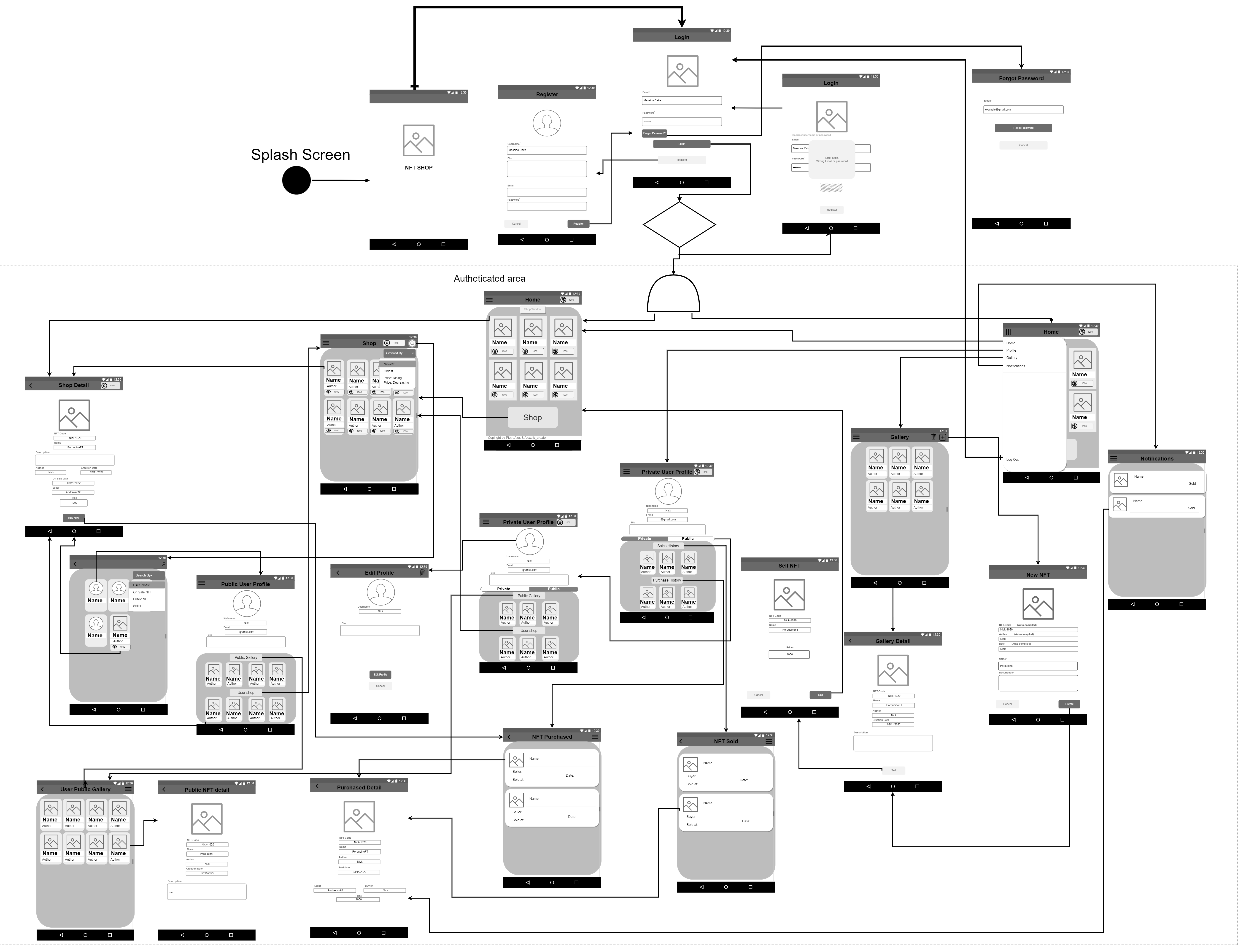

|  |  |
| --- | --- |
|  | Login page:  This view is important because all the app mechanism needs the user  to sign in first. There is a label with the name of the view, in the view’s  body there is the app’s logo and a short set of instructions to log in.  In the middle portion of the screen there is the text field where the user  will insert his username. On tapping the log in button, a success/failure  message will be displayed on the upper portion of the screen.  If the log in is successful the user will be redirected on the home page,  on failure the user will be redirected back on the log in view with an  error message. If there is a new user, he can register to get started on  his NFT adventure. |

|  |  |
| --- | --- |
|  | Registration page:  This is the view where the user can insert his data and chose his username and password to log in, he needs to also load a name and an email to share a contact information, a bio, and a profile photo to be recognizable.  When he presses on register, he will be redirected to the login page, if the cancel is pressed, he will be redirected back to the login without registration.  When the user is successfully registered, the platform will give him a certain amount of internal currency (CASHART). |

|  |  |
| --- | --- |
|  | Home:  This view is the central hub of the app. Here the user can go to all places that the app has. By clicking on one of the shop window’s item, he can go directly to the description page to buy it or simply visualize it; by clicking on the shop button he can go to the complete shop page, also the shop window has every time the last 6 on sale item added.  On the upper right corner, the user has displayed the available currency (CASHART). |

|  |  |
| --- | --- |
|  | Menu:  This is a little menu that the user can use to go anywhere in the app. This menu view is persistent for the whole use of the app, it will be hidden all the time under the 3 stripes icon, sometime the menu is unavailable like in the case of creating a new NFT or selling it, to make sure he doesn’t get mistaken by tapping too much or tapping in a wrong spot.  He can go to the private profile, personal gallery, go back to the home, go to see notifications, and log out the app. We also added the language function for the smooth usability of the app. |

|  |  |
| --- | --- |
|  | Notifications:  This is the view where the user can see and also get notified about the state of all of his “On Sale” items if someone bought one it will be notified to him and also, he can find the detail here, by clicking on the notification it will bring the user to the detail in the history page. |

|  |  |
| --- | --- |
|  | Private Gallery:  Here the user has saved al of his items purchased and not, every item purchased by the user will be saved here. The user can create a new item by clicking on the + in the upper right corner. The app hasn’t at disposal a own editor, so the user need to create it out of the app and then he can load it, every item will be one only, no copy allowed.  If the user wants to see all item details, he can tap on one of them to go to that page. The “trash” icon is used to remove all nfts from the public gallery. |

|  |  |
| --- | --- |
|  | Private Gallery Item Detail page:  This view is used to illustrate all of item’s details, the user can’t change anything here, he can only see and decide to sell the item by pressing on the “sell” button or share it on his public gallery. By clicking the marked text he can see the public section of the author of the NFT. The “trash” icon allows the user to delete the NFT from the app. |
|  | Sell NFT Item:  This page allows the user to sell a new item or just bought one.  He needs to choose a price to sell the item, when done he need to choose to sell it after pressing on the “sell” button or he can press the cancel button to go back.  If the user decides to sell the item, the system will redirect him to the home page where the item will be displayed as “last added” and also it will be added on the complete shop and the item will be deleted from the user gallery. He can also cancel his items in the shop to have them back. |
|  | Publicize items in the Public Gallery:  If the user want to publicize some or all of his items, he can do this by tapping the “share” icon on the bottom right corner, one at a time, and it will be displayed on the public gallery where anyone can see them.  If the user doesn’t want to publicize them, he needs to go back on hi gallery and then click the “trash” icon on the upper right corner. |

|  |  |
| --- | --- |
|  | Public Gallery:  Here the user has all his publicized items.  All users can enter in this page but only the owner can modify it, other users can’t. |

|  |  |
| --- | --- |
|  | New NFT item:  When the user wants to create a new item, he will be redirected onto this page.  He needs to add some information and other can be left blank, some information will be filled by the system because they are based on the app database and system.  When the user is ready to create the item, he needs to click the “create button”, if he doesn’t want to upload it, he needs to click on “cancel” button. |

|  |  |
| --- | --- |
|  | Public Gallery Item Detail page:  Here all users can see all details of the user public gallery. |

|  |  |
| --- | --- |
|  | Private User Profile:  Here the user can find all his information, he has two sections on the lower portion of the profile, by tapping on private (that is the default set for the sections) he can choose to see his private sections with his sales history and purchase history pages, he can go directly to one of them by clicking on their buttons.  Here he can also see his currency.  He can modify his profile image and biography by tapping on them. |
|  | Sales History:  Here the user can see if someone bought one of his on sale items with some information, by clicking on a item the user will be redirected to the detail page of the sale with all of the item information and sales too. |
|  | Purchased History:  Here the user can see some information on his purchased items, by clicking on an item the user will be redirected to the detail page of the sale with all of the item information and sales too. |

|  |  |
| --- | --- |
|  | Purchase Detail page:  Here the user can view all details of his purchased items. |
|  | Sell Detail page:  Here the user can view all details of the sold items. |

|  |  |
| --- | --- |
|  | Public User Profile:  This view is visible by any users, every user can go to this page by tapping on the author or seller information on each on sale item, or he can go to it by the search page where he needs to search it by his username.  The page will display the three last added gallery items and on sale items by the user.  By tapping on “user shop” the user will be redirected to the search page with the research done by the seller. |

|  |  |
| --- | --- |
|  | Shop:  This page is the heart of the application, every on-sale item will be bought here, the user is also shown the currency status.  Here the user can choose what item to buy by clicking on it and he will be brought to the detail shop page.  The shop has also an option to order the items. With this function “order by:” he can choose to display the items by newest, oldest, cheapest or most expensive.  He can also go to the search page by the “search” fab-button on the bottom right corner. |

|  |  |
| --- | --- |
|  | Item Detail Shop Page:  Here the user can see all the item information. He can go directly to the seller or author profile by clicking on its relative button.  If he decides to buy it, if he has enough currency, by clicking on “Buy” he will be redirected to the purchase history, and the system will send a notification to the seller about the sold item. |

|  |  |
| --- | --- |
|  | Search page:  Here the user can search through the whole database every public profile, on sale NFTs and those in public gallery too. |

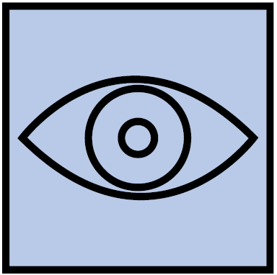Surface

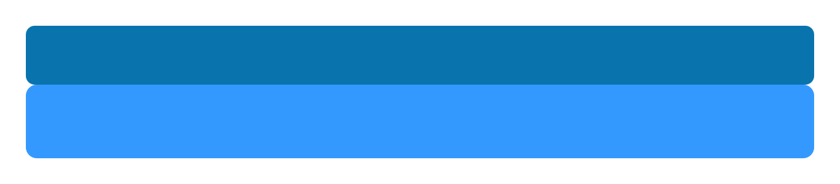

The color light blue relates to balance through all app colors, we gave it because we want to get older and younger artist in this app. We chose to use a simple combination of colors to communicate a sense of uniformity and order, we avoided to use bright colors that could have been annoying for the user.

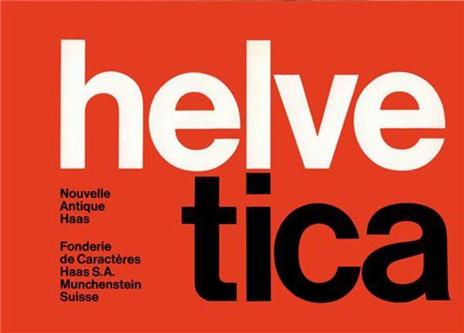

We used the Helvetica as font because it is neutral, clean, legible, versatile, and we want the app as same as the font

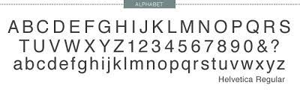

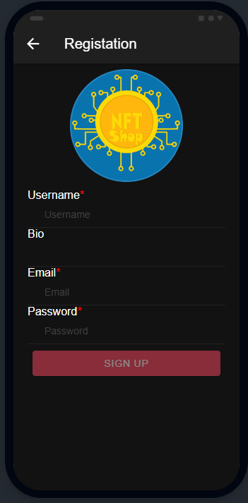Here is the most important page of our application, this form gives all the information needed by the app to give the user a fantastic adventure through art!

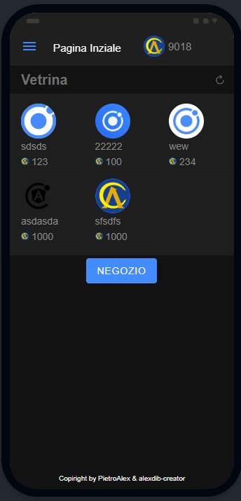

Here is the core of the app, the complete Shop where the user can buy items and sell his own.

With this tool we expect to lead every user to popularity and be successful in the ART world.



The icon has been created combining the classic Bitcoin symbol and the word NFT. The background is rounded and uses one of the colors used inside the app, all the writes and objects on the foreground have a thin shadow that helps to add dimensionality and depth.

NFT Shop: Your Hobby, Your Passion, Your Job, Your Fame©